DAY 1:

* Design the player skeleton in paint

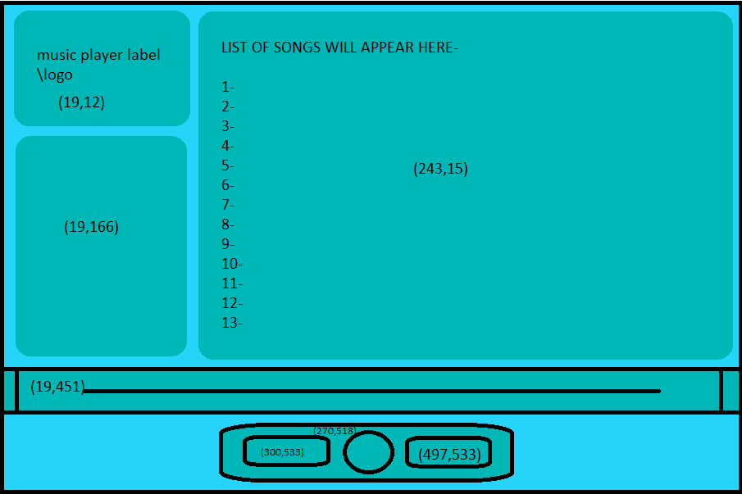

DAY 2:

* Read all documentations related to the requirements for the designing of this product
* Window = Tk(bg=”turquoise2”),

geometry-(900x600)

* Frames
* Logo = Frame(root, bg=”cyan4”,

DAY 3:

* Create the music player by coding it

DAY 4:

* Read all the documents as to how to use media i.e. music in tkinter window
* If possible, try to implement the same in code